Team Builder

Help Manual

Table of Contents

Button Functions…………………………………………………...Page 3

Menu Tabs………………………………………………………....Page 3

Demonstrations…………………………………………………….Page 4

Add Button Demonstration……………………………………………Page 4

Undo Name Button Demonstration……………………………………Page 4

Create Group Button Demonstration………………………………….Page 4

Clear Button Demonstration…………………………………………..Page 4

Open Tab Demonstration……………………………………………...Page 4

Save As Tab Demonstration…………………………………………..Page 4

Button Functions

**Add:** This button has been added to ensure the user can quickly add team members. To use this function, input a single name at the top text box and press the ‘Add’ button. Note: (Add can only input a single name at a time).

**Undo Name:** The purpose of this function is to allow a user to undo a name from the input field in case there was an input error. If the user has found that the last name entered is not correct, click the ‘Undo Name’ button to erase the mistake.

**Create Group:** The ‘Create Group’ button is what the user will be using as the final step to create their teams. This function has two requirements, with those being names and group size. Before pressing this button make sure that the desired team names from the ‘Add’ button have been added. After that has been checked, make sure to enter the team size in the ‘Enter Team Size’ text box. It is now ready to create a group.

**Clear:** This button will reset the entire form when pressed. (Useful for creating another group or team). ‘Clear’ will not delete any saved documents.

Menu Tabs

**Help:** The ‘Help’ tab is designed purposefully so that the user can quickly access important features if they are having trouble. If the user is still having issues, they should consult the manual for more in-depth information.

**Open:** This addition makes it simple to access any documents compatible with the ‘Team Builder’ application. To use this feature, click on the ‘Open’ tab and direct the application to the document that should be opened.

**Save As:** The purpose of this tab is so that the user can save any document and pick where that document will be saved. This makes it easier for a user to save all documents in the same place for easy access. To use the ‘Save As’ feature, click on the ‘Save As’ tab and a window will pop up. Specify where the document should be saved, and the application will then write the document to that location.

Demonstrations

Add Button Demonstration

**Manual Entry:** If you are manually creating a list of names without Opening a list from a file. Simply type in a name in the Name Text Box.

After typing in a name into the Name Text Box, simply click the Add Button and the name should appear in the Name Display Box.

**Non-Manuel Entry:** If you are opening a list from a file, and you have already Opened a list from a file, you can continue on with this demonstration. If you have not Opened a list from a file, you can follow the Open Tab demonstration on Page #.

Once you have your list of names opened into the Name Text Box. Simply click the Add Button to add your names. Your list of names should appear in the Name Display Box.

Undo Name Button Demonstration

If you want to undo a name from the Name Display Box, simply click on the Undo Name Button, and the first name should be undone.

Your Name Display Box should look something like this.

**Before**

**After**

The only time you will not be able to use the Undo Button, is when you have no names in the name display box. Otherwise, you will get an error message saying there are no names in the Name Text Box.

Create Group Button Demonstration

If you have not added your names to the name display box, you can follow the Add Button Demonstration on Page #. Once you have added your names to the Name Text Box, you can enter a Team Size in the Team Size Text Box.

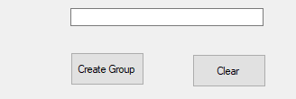

The Team Size Text Box will allow you to pick how big you want your teams to be. Once you have entered a Team Size, click the Create Group Button, and you should have a list of groups in the group Display Box.

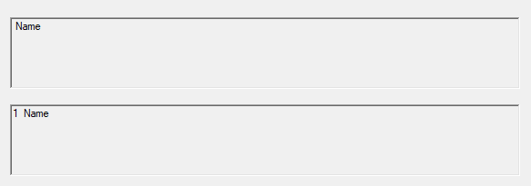

The number associated with the name marks which team that name is on. When entering a team size, you must enter in a number, otherwise you will get this error message.

Clear Button Demonstration

If you want to reset your Name and Team Size text box, along with your display boxes. Simply click the Clear Button.

Your Display Should look something like this.

**Before**

**After**

Open Tab Demonstration

Save As Tab Demonstration